No. | INSTRUCTIONS |  | KEY POINTS / CONTACTS
1. | WHEN THE TRIM GET STUCK INSIDE THE WASHER UNIT  - IDENTIFY THE AREA INSIDE THE WASHER UNIT WITH THE TRIM  - USE CORRECT PPE WHEN HANDLING ANY SCRAP SHEETS OR TRIM STUCK ON SE LINE.  - FOLLOW SHEAR LINE LOCK OUT PROCEDURE. | 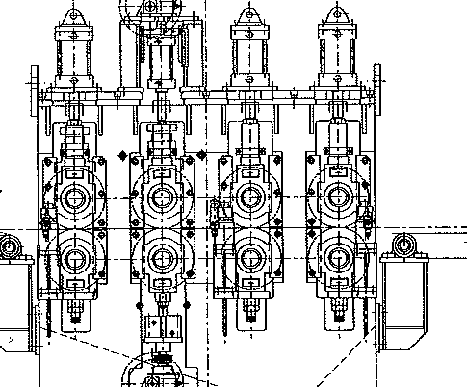  STUCK TRIM  WRINGER ROLLS  BRUSH ROLL  ENTRY PINCH ROLL  SE WASHER UNIT | ENSURE PERSONNAL PROTECTIVE EQUIPMENT (PPE) IS WORN: -  1. HARD HAT  2. STEEL CAP BOOTS  3. WELDING GLOVES  4. LOCKOUT TAGS
2. | BEFORE REMOVING OR WORKING ON THE SHEAR LINE WASHER UNIT.  INFORM:  - PRODUCTION MANAGER  - MAINTENANCE | STOP  CALL  WAIT | LOCK OUT TAGS MUST BE USED WHEN PERFORMING WORK INSIDE THE SHEAR LINE.  FAILLURE TO INFORM RELEVENT DEPARTMENTS CAN RESULT IN EQUIPMENT DAMAGE AND SERIOUS INJURY.

